My Name: _________________________________________ My Email (or parent email): ____________________________________________
Go for a bike ride. | Participate in an organized running/walking event such as a 5K or other specialty races. | Make your own fruit smoothie with fresh fruit. | Go for a family walk after dinner. | Play a board game with family or friends.
Be a volunteer  for an event  or any  other good  cause. | Read a whole book over the summer. | See a movie at a drive-in with your family or friends. | 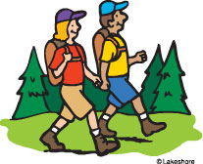  Go for a hike. | Go golfing or  miniature golfing.
Go swimming for 5 different days. | Play an outdoor lawn game such as  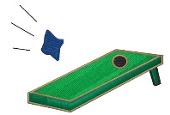  horseshoes,  cornhole,  bocce ball,  Kan Jam, etc. | Unplug/turn off  all of your devices  for a full day. | Go fishing. | Go to a farmer’s market and buy fresh produce.
Build a giant sandcastle at the beach and take a picture with it. | Ride a roller  coaster. | Go kayaking or canoeing. | 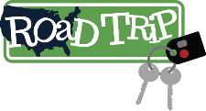  Take a day trip to a fun new location that you’ve never been to before. | Catch lightning bugs/fireflies in  the evening.
Go bowling on a rainy day. | Have a water  balloon battle  with family  or friends. | Go for a morning run/walk on the beach. | Start a garden or weed and plant new flowers/plants. | Play your  favorite  sport  outside.

The Wildcat Wellness Committee invites Halifax Area School District Students, Families, Staff, Staff Families
and Local Community Members to participate in our FREE Summer Wellness Bingo Challenge!
We will be giving away four $25 Dick’s Sporting Goods Gift Cards to the winners!
How to Play:
- Look at the Bingo Card on the reverse side.
- If you complete an activity in a square, then circle that square.
- In order to get Bingo, you need to get 5 in a row (Vertically, Horizontally or Diagonally).
- Every time you get Bingo, your name will be entered into the prize drawing.
  - You may get Bingo up to 5 different ways, but you must use the same card.
  - For each additional Bingo that you get, your name will be entered again for the prize drawing.
    - For example, if you get 3 Bingos, then your name is entered 3 times into the drawing.
    - The maximum number of Bingos that you are allowed to get is 5 unless you get a “blackout card” (see below).
  - If you get a “blackout card” (you completed every square), then your name is entered a total of 10 times into the prize drawing.
When Does it Start:
You may start completing squares on your Bingo card on Friday, June 9th and you have until Sunday, August 27th to complete it.
How Do I Turn in My Bingo Card:
Starting Monday, August 28th, you may turn in your completed Bingo Card to any Halifax Area School District Office. Please make sure your name and email address is filled in on the card. All Bingo Cards must be turned in by Wednesday, September 6th.
How Do I Win:
Your name will entered in a random drawing based on the number of Bingos you get. All winners will be selected and notified on Friday, September 8th.
For more information or to print out additional Bingo cards for family and friends, go to Halifaxwellness.weebly.com
is also on . Be sure to us to stay up to date with HASD wellness initiatives.

